**Start-Ups**

**Team** - SynTech-X

**Problem Definition/ Analytics Objective**

The objectives of a start-up are to be one’s own boss and to create employment to others which warrants lot of endurance and sacrifice. Large population with high percentage of middle income group, educated youth with technical background, IT domination, high internet and mobile penetration are some of the drivers that have thrown up opportunities for spreading start-up revolution in India. The ‘Make-in-India’ initiatives and other government schemes have also given a boost to start-ups with many individuals entering the fray. Starting a venture is a well-planned and disciplined exercise with due consideration of both internal and external factors that may impact the sustainability of the venture. The idea behind the venture, market size, revenue and profit targets are some of the important factors that need to be clearly defined before embarking on the journey. Time, team work and tenacity are important elements which determine entrepreneurial success. Infrastructure, government regulations and availability of finance at various stages of growth could be some of the challenges for start-ups. In fact, history is replete with examples of start-ups which began with big fanfare but ended as damp squibs within a short span of time due to various reasons.

Too often analysis is started without a clear idea of where it is going. The result is usually a lot of wasted time and an inadequate analysis. Avoid this by deciding on the objectives of the analysis before starting it.

Steps for Analytics Objective are:

1. Prepare the Data

Construct the variables needed for analysis.

1. Descriptive analysis

Calculation of summary tables and graphs, as defined when setting objectives.

1. Confirmatory analysis

This is the formal analysis, mainly aimed at:

* Adding measures of precision to the results found in the descriptive analysis.
* Improving the estimates of various critical quantities.

1. Interpretation

This is not just about understanding the meaning of a statistical test, but the whole job of integrated the new knowledge with the existing body of knowledge on the problem.

1. Reporting

Reporting the analysis and presenting the final tables and graphs.

**Approach Description**

The Lean Start-up provides a scientific approach to creating and managing start-ups and get a desired product to customers' hands faster. The Lean Start-up method teaches you how to drive a start-up how to steer, when to turn, and when to persevere-and grow a business with maximum acceleration. It is a principled approach to new product development.

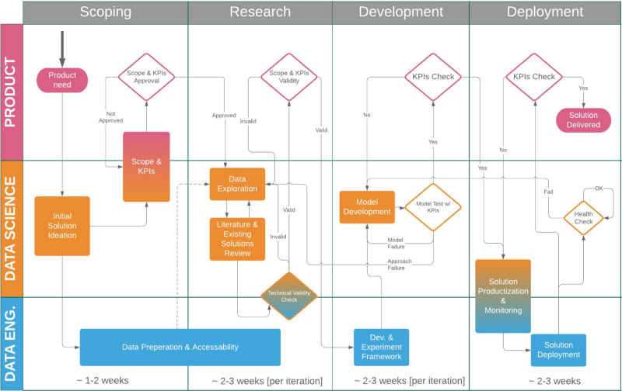

There are three distinct approaches to the motivational phenomena to ensure and boost worker productivity. They are the stick approach, the carrot approach and the combined carrot and stick approach.

1. **The Stick or Authoritarian approach**

This approach represents the oldest or classical view which compels performance through threats of penalties for failure. The industrialist was a dictator. He believed that might is right. With stick in hand the manager controls his subordinates.

This was in vogue in the days of slavery. There are instances of slaves put to death for not doing what they were told to do.

During these periods workers were completely under the thumb of their masters, subject to arbitrary overtime, arbitrary punishment, arbitrary fines and arbitrary dismissal.

ADVERTISEMENTS:

This approach is still followed in prison and military administration in all countries. In effect, the management tells the employee, ‘Do what I tell you, otherwise I will sack you.’

This approach represents a negative attitude. Without positive motivation no good result can be obtained. The threat of punishment may dampen the spirit of the employees.

1. **The Carrot or Paternalistic approach**

This approach suggests that employees should be treated in a fatherly way as if the business organisation is a family and they are its dependent members. The employees are given rewards unconditionally.

There is only carrot and no stick. The employers think that because of these rewards the employees will remain loyal and grateful and work hard,

This approach does not motivate the workers. Ordinary workers do not have that sense of gratitude which the paternalist manager expects from them. So unconditional rewards will be just absorbed by them without any reciprocities behaviour.

If one man has to play the role of benevolent supervisor, another has to play the role of grateful subordinate. No man can play the role of paternalistic employer successfully unless others will play the reciprocal roles of child-like employees.

Paternalism means that papa know best. Management tells the employee- ‘You do what I tell you because I shall look after your needs.’ By its very nature the paternalistic approach is unlikely to work with mature adult employees many of whom do not like their interests to be looked after by a “god father”. They regard themselves as more competent to do so.

This approach, however, can work, when the existing socio-cultural structure is congenial to the type of superior-subordinate relationship as in Japan and India and there are no strong labour organisations to challenge the manager’s decisions about what should be done for the employees.

1. **The Carrot and Stick or Exchange approach**

This combined approach suggests that with the stick in one hand, the manager will extract work against the threat of penalty and with the carrot in another; he will induce the worker to work harder in the hope of good rewards.

The carrot and a stick approach is essentially a penalty-reward approach. If the worker produces more, he is given a bonus and if he produces less, he is penalised.

The carrot approach provides for unconditional rewards, whereas the carrot and stick approach provides for both rewards and penalties which are linked directly to the level of performance.

This approach can be identified with Taylor’s Differential Piece Rate System or with incentive wages system of modern times. It is also known as an exchange theory because it proposes to purchase quality and quantity of output.

But the incentive scheme is not quite sound. It is based on the assumptions that the worker is fundamentally and continually motivated by economic considerations. The Hawthrone experiments proved that financial incentives are not enough.

It is being increasingly realised that an employee works to satisfy some basic needs within himself. Consequently, high employee productivity can be obtained when the organisation provides adequate opportunities for satisfaction of those needs through the work done.

In other words, a high producing organisation is one which has achieved maximum congruence between the organisation needs and employee needs.

Reasons to adopt the approach

1. ELIMINATE UNCERTAINTY

The lack of a tailored management process has led many a start-up or, as Ries terms them, "a human institution designed to create a new product or service under conditions of extreme uncertainty", to abandon all process. They take a "just do it" approach that avoids all forms of management. But this is not the only option. Using the Lean Start-up approach, companies can create order not chaos by providing tools to test a vision continuously. Lean isn't simply about spending less money. Lean isn't just about failing fast, failing cheap. It is about putting a process, a methodology around the development of a product.

1. WORK SMARTER NOT HARDER

The Lean Start-up methodology has as a premise that every start-up is a grand experiment that attempts to answer a question. The question is not "Can this product be built?" Instead, the questions are "Should this product be built?" and "Can we build a sustainable business around this set of products and services?" This experiment is more than just theoretical inquiry; it is a first product. If it is successful, it allows a manager to get started with his or her campaign: enlisting early adopters, adding employees to each further experiment or iteration, and eventually starting to build a product. By the time that product is ready to be distributed widely, it will already have established customers. It will have solved real problems and offer detailed specifications for what needs to be built.

## VALIDATED LEARNING

Progress in manufacturing is measured by the production of high quality goods. The unit of progress for Lean Start-ups is validated learning-a rigorous method for demonstrating progress when one is embedded in the soil of extreme uncertainty. Once entrepreneurs embrace validated learning, the development process can shrink substantially. When you focus on figuring the right thing to build-the thing customers want and will pay for-you need not spend months waiting for a product beta launch to change the company's direction. Instead, entrepreneurs can adapt their plans incrementally, inch by inch, minute by minute.

**Data Exploration**

There are number of key skills to identify the data issue.

1. Thinking as a data scientist:

This is the most in-demand skill in data science. When you plan to hire a data scientist or outsource development the first thing you need to see is whether the concerned person or company has a data-driven approach or not. Thinking as a data scientist refers to the intellectual curiosity that pushes people to look for solutions and relations they never thought would exist. The whole point of doing data analysis in the first place is to look at the problem in hand and figure out solutions using data. You need to test the acumen of the company by asking real life business problems and analyse their approach to solving it.

1. Ability to setup a layman language:

There are many issues regarding how a communication is established between data scientists and executives. The language involved in the communicating data insights is too complex to be understood by managers from a non-technical background. It needs to be ensured that whatever insights are generated are communicated properly in an easy to understand language. The big question is how to define that language. While outsourcing projects ensure that a person with requisite knowledge of both data science and business is involved. This will ensure that you fully understand the insights without getting into too many technical details.

1. Past track record:

There are many companies who are trying to get into big data analysis. Be it startups or MNCs, big data has become a buzzword for every executive. With so many companies defining themselves as big data experts it necessary that you separate clutter from the pile. What can really help you choose experts is select companies which have previously done big data analysis for some other clients. Alternatively, you can look at the LinkedIn profiles of persons you communicated with. This will also give you insights on the capabilities and market potential of company’s executives.

1. Technical skills:

Your data scientists should be well versed to handle the technical side of big data analytics. The technical knowledge can ideally be divided into statistics, advanced programming, cloud computing and big data tools.

* Having knowledge of **statistical analysis** helps to make sense out of data and drive insights. This involves in-depth knowledge of statistical methods, multivariable calculus, and linear algebra.
* **Advanced programming** involves working on complicated algorithms based on machine learning and data analysis. It involves hands on experience on languages like R and Python.
* It is a great add-on if the company's team also has **knowledge of cloud computing** solutions like Amazon S3 and working on data tools on cloud platforms.
* **Big data tools** involve frameworks that are used to work on big data like Hadoop, Hive, Pig etc. It also includes knowledge of [big data visualization tools](https://www.newgenapps.com/blog/10-big-data-visualization-tools) like Tableau, QlikView, Plotly etc.

These technical skills collectively bring out the insights in big data. It is important to ensure that your vendor has these skills and is capable of dealing with all forms of data whether it is organized or unorganized. You can probably hire a consultant or involve someone from your company's IT team in conversation with the prospective vendor.

1. Business Acumen:

While looking for data scientist you are essentially looking for people who can not only analyze data but also advice on selecting the right business problems to solve and how you should use your big data. This needs a solid understanding of the industry workings and the impact of insights on business decisions. In addition to identifying new ways in which you can leverage your data, you also need to prioritize business problems and identify data sets that can be analysed to solve the issue. This guidance can only be given by people who have business acumen along with the key data science skills, to guide your efforts in right direction.

Approach to solve issues

Step 1: Define the problem

First, it’s necessary to accurately define the data problem that is to be solved. The problem should be **clear, concise, and measurable**. Many companies are too vague when defining data problems, which makes it difficult or even impossible for data scientists to translate them into machine code.

Here are some basic characteristics of a well-defined data problem:

* The solution to the problem is likely to have enough positive impact to justify the effort.
* Enough data is available in a usable format.
* Stakeholders are interested in applying data science to solve the problem.

Step 2: Decide on an approach

There are many data science algorithms that can be applied to data, and they can be roughly grouped into the following families:

* **Two-class classification**: useful for any question that has just two possible answers.
* **Multi-class classification**: answers a question that has multiple possible answers.
* **Anomaly detection**: identifies data points that are not normal.
* **Regression**: gives a real-valued answer and is useful when looking for a number instead of a class or category.
* **Multi-class classification as regression**: useful for questions that occur as rankings or comparisons.
* **Two-class classification as regression**: useful for binary classification problems that can also be reformulated as regression.
* **Clustering**: answer questions about how data is organized by seeking to separate out a data set into intuitive chunks.
* **Dimensionality reduction**: reduces the number of random variables under consideration by obtaining a set of principal variables.
* **Reinforcement learning algorithms**: focus on taking action in an environment so as to maximize some notion of cumulative reward.

Step 3: Collect data

With the problem clearly defined and a suitable approach selected, it’s time to collect data. All collected data should be organized in a log along with collection dates and other helpful metadata.

It’s important to understand that collected data is seldom ready for analysis right away. Most data scientists spend much of their time on **data cleaning**, which includes removing missing values, identifying duplicate records, and correcting incorrect values.

Step 4: Analyse data

The next step after data collection and clean-up is data analysis. At this stage, there’s a certain chance that the selected data science approach won’t work. This is to be expected and accounted for. Generally, it’s recommended to start with trying all the basic machine learning approaches as they have fewer parameters to alter.

There are many excellent [open source](https://brainhub.eu/blog/writing-good-documentation-open-source-library/) data science libraries that can be used to analyse data. Most data science tools are written in Python, Java, or C++.

Step 5: Interpret results

After data analysis, it’s finally time to interpret the results. The most important thing to consider is whether the original problem has been solved. You might discover that your model is working but producing subpar results. One way how to deal with this is to add more data and keep retraining the model until satisfied with it.

Consolidate Information out of data

As companies continue to invest heavily in IT systems, the complexity of integration increases along with the need and cost of ongoing maintenance.

* Server sprawl is a challenge faced by many IT departments as organizations expand and grow.
* Branch offices have created a distribution of data and systems at multiple locations giving birth to a plethora of business information challenges. One of the leading reasons for IT consolidation and IT rationalization plans of large enterprises is support for remote offices.
* New technologies and multiple vendors have added to the patch-and-grow dilemma.

IT consolidation can help reduce the complexity of existing IT infrastructure in a number of ways:

* Increased system availability. High availability, reduced downtime, and optimal disaster recovery.
* Improve responsiveness. A flexible and scalable IT environment that can quickly adapt to future growth.
* Reduced costs. Reduced licensing costs, centralized storage, streamlined centralized operations and management of workstations, servers, and networks.
* Improved security. Less endpoints for attack and greater management control with centralized data systems.

IT consolidation is not just about the hardware. Applications and database consolidation can improve performance and streamline resources by eliminating redundancies and combining multiple applications and databases into a cohesive IT environment.

IT consolidation analysis and strategy are the first steps to streamlining your IT management and improving the decision making process at your organization.

Exploratory skills and data preparation strategies

EDA is valuable to the data scientist to make certain that the results they produce are valid, correctly interpreted, and applicable to the desired business contexts. Outside of ensuring the delivery of technically sound results, EDA also benefits business stakeholders by confirming they are asking the right questions and not biasing the investigation with their assumptions, as well as by providing the context around the problem to make sure the potential value of the data scientist’s output can be maximized. As a bonus, EDA often leads to insights that the business stakeholder or data scientist wouldn’t even think to investigate but that can be hugely informative about the business.

**Data Analysis**

1.) Analytical Skills

As the name implies, it is clear that analytical skills are of huge importance in data analysis. These skills refer to the ability to gather, view and analyze all forms of information in details. They also mean the ability to view a challenge or situation from different perspectives.

Analytical skills are major data analyst skills that make it possible for you to address problems by making decisions in the most appropriate way. Hence, if you wish to become a successful data analyst, you need to acquire and improve your analytical skills and thinking.

2.) Numeracy Skills

These refer to mathematical skills which include a wide range of abilities including:

1. Have good knowledge of figures and numbers
2. Understand the relationships existing between numbers

* Interpret any mathematical information

1. Have the ability to organize information
2. Be able to schedule or budget
3. Be conversant with trends
4. Know how to measure and analyze data
5. Be able to work with graphical information
6. Possess calculation skills

3.) Technical and Computer Skills

Good computer and data analyst technical skills are among the important data analytics skills. You should possess a basic knowledge of statistics. Also, you need to be familiar with some computer software and tools including; scripting language (Matlab, Python), Querying Language (SQL, Hive, Pig), Spreadsheet (Excel) and Statistical Language (SAS, R, SPSS). Other computer skills include; programming (Javascript, XML), big data tools (Spark, Hive HQL) and so on.

4.) Attention to Details

These are also important data analytics tools that any intending data analyst must develop. Ability to pay attention to details allows a data analyst find and see initially unseen details and links. This ability is especially important at the point of solving problems and making decisions. One who pays attention to details to work better and stands lower risk of making errors.

Employers do not joke with this strength, this explains why many people include attention to details ability in their résumés and job applications.

5.) Business Skills

You also need to possess certain business skills to function well as a data analyst. The major business skills you need include:

* Decision-making and problem-solving skills: These two work together. This is the main crux of data analysis as the job of a data analyst is to give the right information for decision-making and problem-solving process.
* The ability to acquire knowledge on new things, especially with regards to technological developments.
* Communication skills: As a data analyst, it is expected of you to work with different people in your team. You should be able to communicate effectively with directors and co-workers to prepare, present and explain data.
* Time management and organization skills: Your ability to manage time effectively will enable you handle your responsibilities and meet deadlines.

6) Communication Skills

[Data Analytics job](http://www.digitalvidya.com/blog/data-analysis-jobs/) requires you to be an excellent communicator. In other words, you must be able to facilitate meetings, make the right requests and be an active listener in order to assimilate new information. Your communication proficiency should also cut across different digital platforms such as internet, conference calls, SMS among others. The nature of this job requires you to spend a significant amount of time relating with management, users, developers and clients. You really do not want to disappoint any of these categories of people.

There are 5 statistical skills in data analysis

* 1. Critical Thinking and Problem Solving

High-level data analysts know how to conduct experiments, test hypotheses and make causal inferences from the data at their disposal. More broadly, they can think creatively about problems — for example, how to translate decision makers’ business-related questions into useful questions about data. As software takes over a growing number of tasks, the value of data analysts may depend more and more on their ability to apply human judgment to business challenges. Machine learning (ML) and artificial intelligence (AI) may therefore make critical thinking and problem-solving skills even more crucial in the future.

* 1. Statistics

Data analytics revolves around the statistical analysis of data. Strong quantitative skills are thus an essential part of the data analyst’s toolkit, although different jobs may require different levels of mathematical understanding. At a minimum, professionals in this field should have a solid grasp of basic statistics; senior data analysts may be skilled in techniques such as multivariate A/B testing, predictive modelling, trend analysis, and cluster analysis. A theoretical understanding of these concepts is not enough, as analysts need to know how to apply these skills to answer practical business questions.

* 1. Data Management, Querying & Analysis

Simply put, data analysts have to be comfortable working with data. That means they have to be skilled at collecting, organizing and manipulating large amounts of data using databases and other technologies. Above all, they need to understand how to find and extract the specific data they need to perform their analyses. Knowledge of SQL, or Structured Query Language, is virtually a universal requirement: SQL allows analysts to code their own customized queries and pull extremely detailed data from relational databases. To work with large datasets using frameworks such as Hadoop, analysts might have to learn an additional query language such as HiveQL. Given the high rate of change in the field, data analysts have to be adept at upgrading their data skills and learning new data technologies.

* 1. Programming

A strong knowledge of programming is useful and often necessary, since analysts may have to solve problems that ready-made software is not powerful or flexible enough to handle. In such cases, they may need to write their own code, tailored to their specific datasets and business questions. [R and Python](https://qz.com/1063071/the-great-r-versus-python-for-data-science-debate/) are the most popular languages for data analytics: R excels at developing programs for statistical analysis, while Python is often useful for automating repetitive tasks and creating visualizations of data. Other programming languages, such as MATLAB, may also be useful for solving certain challenges. Programming skills may only become more essential for data analysts in years to come, as companies face the challenge of extracting more and more sophisticated insights from ever larger amounts of data.

* 1. Machine Learning and Artificial Intelligence

With advances in machine learning, more and more analytic tasks will be delegated to intelligent systems that can not only detect patterns in data, but also learn with experience and improve their own performance. For example, using an enterprise customer data platform like Arm [Treasure Data](https://www.treasuredata.com/), analysts can help identify valuable customer segments and begin to apply predictive analytics by assessing the likelihood of future events. This trend will change the data analyst’s role in unpredictable ways. More and more, analysts may need to understand how to apply AI tools and approaches to real-world problems, while machines take over the more routine or repetitive aspects of data analysis. Knowledge of deep learning frameworks and AI is currently desirable for some senior data analyst positions, and analysts with a strong programming background may find themselves working with data scientists to develop new machine learning solutions.

Non-statistical Skills in Data Analysis

* 1. A string Business Acumen

Effective data analysts combine statistical and technical skills with the ability to understand the specific challenges facing their companies and decision makers. It thus helps for analysts to have extensive knowledge of their specific industries, as well as the business functions they serve inside the company. For instance, a data analyst charged with providing recommendations to a company’s marketing executives is likely to need a strong grasp of marketing strategy and tactics.

* 1. Strong Communication Skills

To help decision-makers, data analysts have to tell stories with data and convey their findings in an accessible, informative way. As a result, they need the ability to create effective visual aids such as graphs, diagrams, and dashboards — a task that may require programming or business intelligence tools. Excellence in written and verbal communication is also a must for analysts. Over time, data analysts may find themselves working with personnel in a wider variety of roles, as data becomes more and more essential to decision making throughout their organizations. Consequently, the ability to speak to and interact with different audiences may become more important than ever.

Descriptive / Prescriptive analytical skills

90% of organizations today use descriptive analytics which is the most basic form of analytics. The simplest way to define descriptive analytics is that, it answers the question “What has happened?”. This type of analytics, analyses the data coming in real-time and historical data for insights on how to approach the future. The main objective of descriptive analytics is to find out the reasons behind precious success or failure in the past. The ‘Past’ here, refers to any particular time in which an event had occurred and this could be a month ago or even just a minute ago. The vast majority of big data analytics used by organizations falls into the category of descriptive analytics.

Big data might not be a reliable crystal ball for predicting the exact winning lottery numbers but it definitely can highlight the problems and help a business understand why those problems occurred. Businesses can use the data-backed and data-found factors to create prescriptions for the business problems, that lead to realizations and observations.

Prescriptive analytics is the next step of predictive analytics that adds the spice of manipulating the future. Prescriptive analytics advises on possible outcomes and results in actions that are likely to maximise key business metrics. It basically uses simulation and optimization to ask “What should a business do?”

Prescriptive analytics is an advanced analytics concept based on –

1. Optimization that helps achieve the best outcomes.
2. Stochastic optimization that helps understand how to achieve the best outcome and identify data uncertainties to make better decisions.

Overall Approach

Quantitative research

Quantitative research is generally associated with the positivist/post positivist paradigm. It usually involves collecting and converting data into numerical form so that statistical calculations can be made and conclusions drawn.

* 1. The process

Researchers will have one or more hypotheses. These are the questions that they want to address which include predictions about possible relationships between the things they want to investigate (variables). In order to find answers to these questions, the researchers will also have various instruments and materials (e.g. paper or computer tests, observation check lists etc.) and a clearly defined plan of action.

Data is collected by various means following a strict procedure and prepared for statistical analysis. Nowadays, this is carried out with the aid of sophisticated statistical computer packages. The analysis enables the researchers to determine to what extent there is a relationship between two or more variables. This could be a simple association (e.g. people who exercise on a daily basis have lower blood pressure) or a causal relationship (e.g. daily exercise actually leads to lower blood pressure). Statistical analysis permits researchers to discover complex causal relationships and to determine to what extent one variable influences another.

* 1. Principles

Objectivity is very important in quantitative research. Consequently, researchers take great care to avoid their own presence, behaviour or attitude affecting the results (e.g. by changing the situation being studied or causing participants to behave differently). They also critically examine their methods and conclusions for any possible bias.

Researchers go to great lengths to ensure that they are really measuring what they claim to be measuring. For example, if the study is about whether background music has a positive impact on restlessness in residents in a nursing home, the researchers must be clear about what kind of music to include, the volume of the music, what they mean by restlessness, how to measure restlessness and what is considered a positive impact. This must all be considered, prepared and controlled in advance.

Qualitative research

Qualitative research is the approach usually associated with the social constructivist paradigm which emphasises the socially constructed nature of reality. It is about recording, analysing and attempting to uncover the deeper meaning and significance of human behaviour and experience, including contradictory beliefs, behaviours and emotions. Researchers are interested in gaining a rich and complex understanding of people’s experience and not in obtaining information which can be generalized to other larger groups.

1. The process

The approach adopted by qualitative researchers tends to be inductive which means that they develop a theory or look for a pattern of meaning on the basis of the data that they have collected. This involves a move from the specific to the general and is sometimes called a bottom-up approach. However, most research projects also involve a certain degree of deductive reasoning (see section on quantitative research for more details).

Qualitative researchers do not base their research on pre-determined hypotheses. Nevertheless, they clearly identify a problem or topic that they want to explore and may be guided by a theoretical lens - a kind of overarching theory which provides a framework for their investigation.

1. Principles

Researchers will tend to use methods which give participants a certain degree of freedom and permit spontaneity rather than forcing them to select from a set of pre-determined responses (of which none might be appropriate or accurately describe the participant’s thoughts, feelings, attitudes or behaviour) and to try to create the right atmosphere to enable people to express themselves. This may mean adopting a less formal and less rigid approach than that used in quantitative research.

It is believed that people are constantly trying to attribute meaning to their experience. Therefore, it would make no sense to limit the study to the researcher’s view or understanding of the situation and expect to learn something new about the experience of the participants. Consequently, the methods used may be more open-ended, less narrow and more exploratory (particularly when very little is known about a particular subject). The researchers are free to go beyond the initial response that the participant gives and to ask why, how, in what way etc. In this way, subsequent questions can be tailored to the responses just given.

**Results and Conclusions**

Data consolidation refers to the collection and integration of data from multiple sources into single destinations.

During this process different data sources are put together, or consolidated into a single data store.

There are various reasons for the start-up fail.

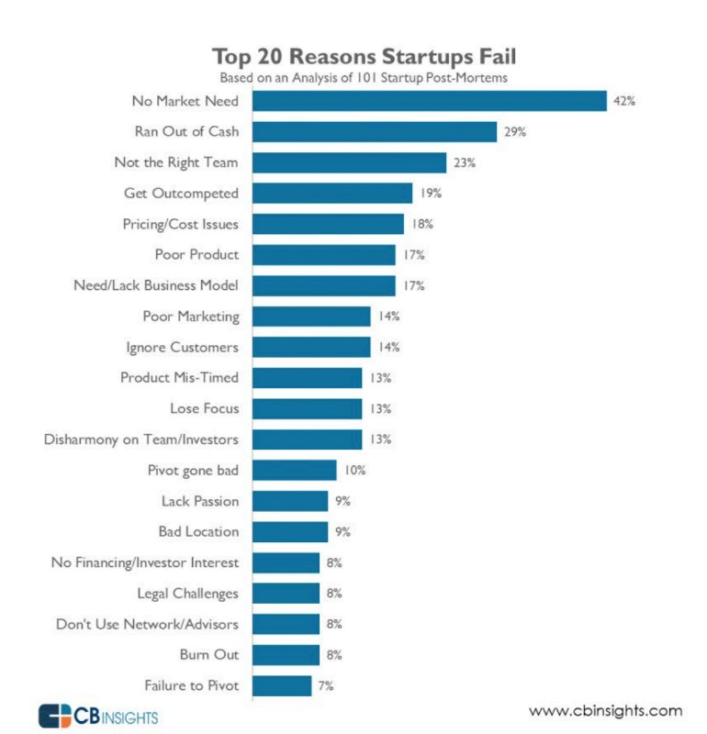

Solutions to avoid failure of start-ups

1. Go out, talk to people before you start building your product.
2. Research your industry, it is easier and cheaper to make changes in the idea stage.
3. Analyse if your customer acquisition strategy is scalable.
4. Practically estimate your sales cycle and return on investment.
5. Management should take its own decisions.
6. Over communication within the team is always better than under communication.
7. Keeping a track of accounts and how long company can run given current circumstances.
8. Be in touch with more than one investor to increase odds of funding and build a network soon.
9. Refrain from cost saving and putting amateur talent to build products.
10. Marketing should not start only when the product is completed, it should begin much early.

**Implications**

Stakeholders are those who may be affected by or have an effect on an effort.  They may also include people who have a strong interest in the effort for academic, philosophical, or political reasons, even though they and their families, friends, and associates are not directly affected by it.

One way to characterize stakeholders is by their relationship to the effort in question.

* Primary stakeholders are the people or groups that stand to be directly affected, either positively or negatively, by an effort or the actions of an agency, institution, or organization.  In some cases, there are primary stakeholders on both sides of the equation: a regulation that benefits one group may have a negative effect on another.  A rent control policy, for example, benefits tenants, but may hurt landlords.
* Secondary stakeholders are people or groups that are indirectly affected, either positively or negatively, by an effort or the actions of an agency, institution, or organization.  A program to reduce domestic violence, for instance, could have a positive effect on emergency room personnel by reducing the number of cases they see.  It might require more training for police to help them handle domestic violence calls in a different way.  Both of these groups would be secondary stakeholders.
* Key stakeholders, who might belong to either or neither of the first two groups, are those who can have a positive or negative effect on an effort, or who are important within or to an organization, agency, or institution engaged in an effort.  The director of an organization might be an obvious key stakeholder, but so might the line staff – those who work directly with participants – who carry out the work of the effort.  If they don’t believe in what they’re doing or don’t do it well, it might as well not have begun.  Other examples of key stakeholders might be funders, elected or appointed government officials, heads of businesses, or clergy and other community figures who wield a significant amount of influence.

CustomerDimension: Includes factors like customer feedback, product or service acceptability, customer referrals, user-friendliness, value for money for customer etc.

MarketDimension: Includes factors like market demand, pull factors, ease to market, advertising and promotions, understanding the market need, pricing and market mix factors etc.

The data is divided into 2 parts:

1. The companies which are closed (0).
2. The companies which are still in working (1).

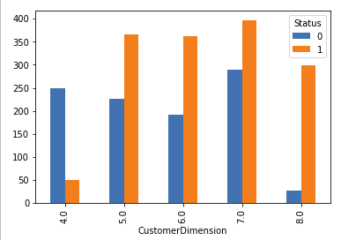

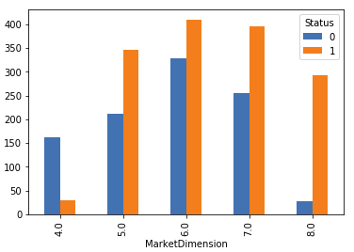

FinanceDimension: Includes factors like availability of finance, ease with operating cash, cash cycle, liquidity, ease of credit repayment, healthy income etc

HRDimension: Includes factors like talent retention, employee motivation, ease of recruitment, employee salaries, mutual trust between key players, healthy working environment, harmony of employees and stakeholders etc.

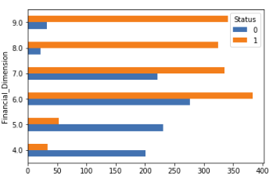

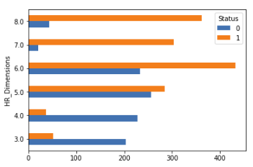

ManagementDimension: Includes factors like ability, credibility, stability and professionalism in management, support to projects, consistent and conducive management environment etc.

StrategicDimension: Includes factors like business strategy formulation and implementation, commitment to vision, mission and organizational objectives, credibility of strategic initiatives etc

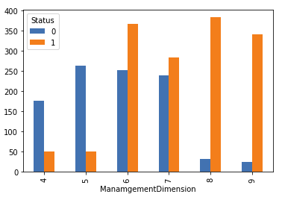

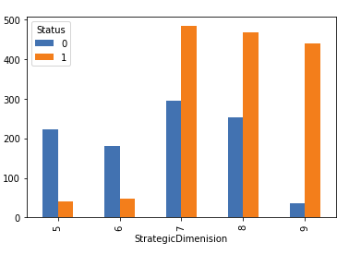

OperationalDimension: Includes factors like ease of procurement, logistics, transportation, inventory, suppliers, distributors etc.

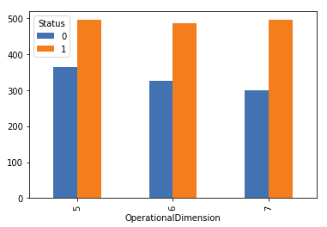

Industry_Vertical: Industry vertical or Nature of Business

SubVertical: Main sub vertical or first major work of business

City: Location in India

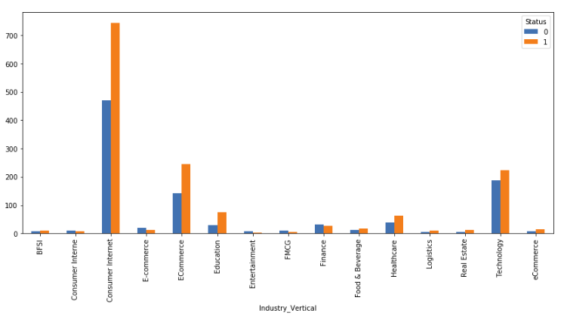

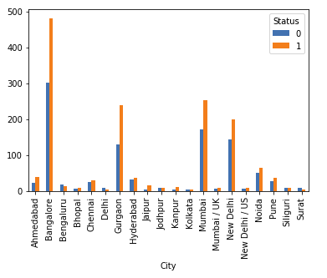

IndustryPerformance: Overall Industry Performance (High, Medium Low).

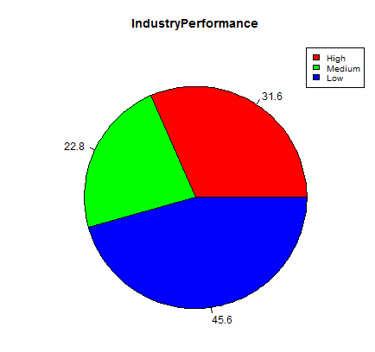

InvestmentType: Type of initial funding e.g. debt, seed, private etc.

Invest_1st_Q_S: Investments in the first quarter of the start year.

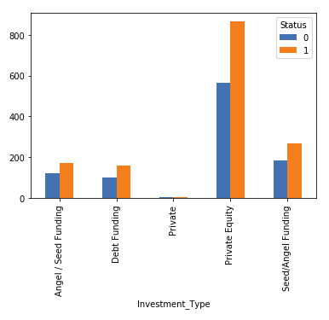

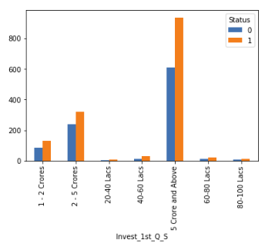

Year_of_start: Year of the official start of start-up.

Emp1_cnt_Y1: Average number employees in year 1 (1st year).

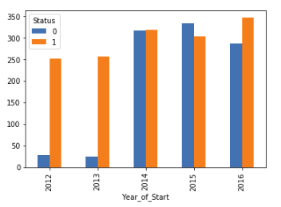

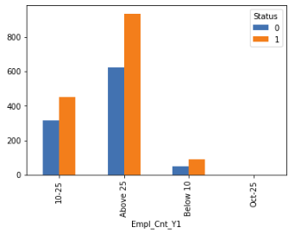

Id (Notclosed list): Start-up Identifier, This is a list of startups which are still up and running as of Dec 2017.

Id (Closed list): Start-up Identifier, This is a list of startups which are closed in the period, Jan – Dec, 2017.